

**ARE YOU**

**STILL**

**PAYING A MONTHLY**

**FEE FOR YOUR**

**F&I MENU?**

**TO MORE F&I INCOME**

**GET STARTED WITHIN 48 HOURS**

0621-V01

**WWW.DEALERNETWORKSERVICE.COM**



**STEP 1:**

**Sign up for our Finance and instantly gain access to lenders in your**

**state who specialize in indirect auto financing.**

**STEP 2:**

**Implement our F&I Menu at no cost to provide a seamless selling**

**Interface for all your *existing* warranty providers.**

**STEP 3:**

**Add in at least one of our products (VSC/GAP/Bundle/Etc.) to**

**maximize your F&I revenue.**

**THREE EASY STEPS**

**DEALER NETWORK**

**SERVICE**

**Close More Deals**

**Sell More Product**

**Make More Gross**

**Do not wait**

**Start today**



**ALL YOUR LENDERS & WARRANTY PROVIDERS, INSIDE ONE INTERFACE**

**WWW.DEALERNETWORKSERVICE.COM**

0621-V01

**For Information Call**

507-390-2248

**EASY TERM FINANCING**

**Flexible rates and terms, all preloaded inside the F&I Menu.**

**•**

**Rates as low as 5.99%**

**•**

**Up to 5% dealer profit paid**

**•**

**Up to 125% LTV of NADA RETAIL + VSC and Gap**

**•**

**Max mileages of 150k and model years vary on credit**

**•**

**Aggressive backend allowances**

**•**

**Additional ancillary products allowed**

**•**

**640**

**and better credit scores financed**

**•**

**Integrated with Route One and Dealer Track**

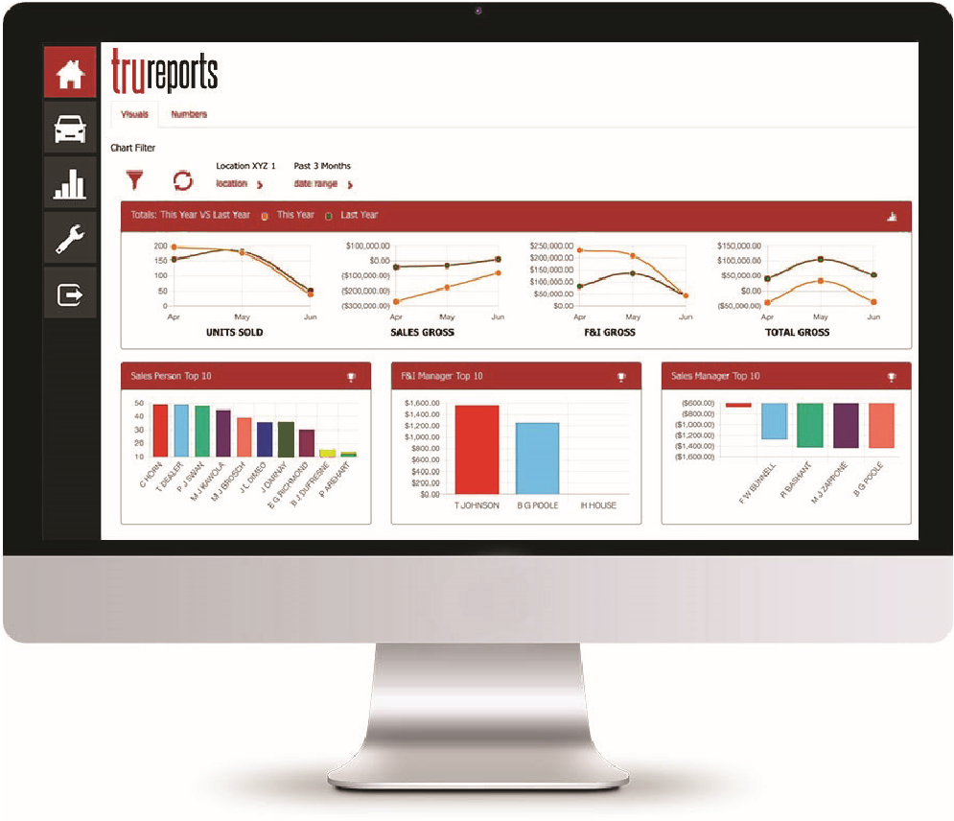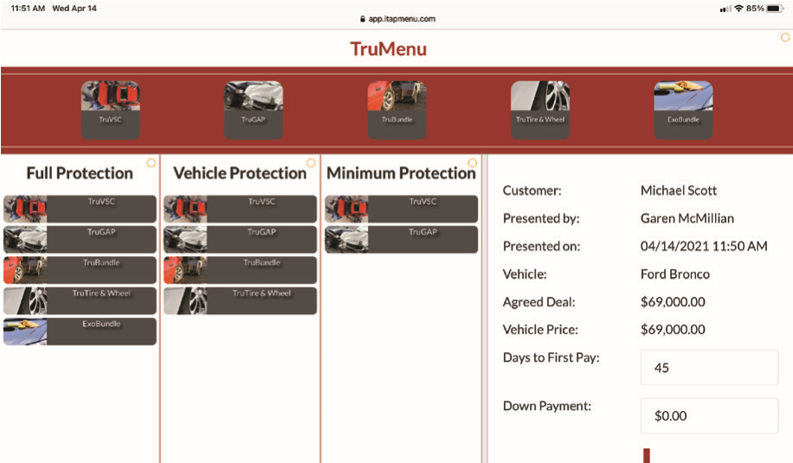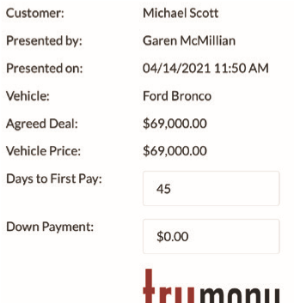

**menu**

**STEP 1: F&I MENU**

**•**

**Fully functional F&I menu at no cost to anyone. No monthly**

**fees. No strings attached.**

**•**

**Display all your *existing* warranty providers inside**

**the Menu. Yes this is real.**

**•**

**Easy-to-use selling interface means your dealership sells**

**more.**

**STEP 2: ADD GAP, WARRANTY & Etc..**

**•**

**We provide you with the full suite of products**

**GAP, Warranties & Bundles**

**•**

**No minimum volume requirements Sell more make more**

**OUR SUCCESS IS DRIVEN BY YOUR SUCCESS**

**•**

**Aggressive pricing ensures your dealerships maximize**

**revenue**



**DEALER NETWORK**

**SERVICE**